BARBIE BUNGEE!!!! MSDS Summer 2021!!!!!

Virtual Hybrid Style!

|  |  |  |  |  |  |  |  |  |  |  |  |  |  |  |  |  |  |  |  |  |  |  |  |  |  |  |  |  |  |  |  |  |  |  |  |  |  |  |  |  |  |  |  |  |  |  |  |  |  |  |  |  |  |  |  |  |  |  |  |  |  |  |  |
| --- | --- | --- | --- | --- | --- | --- | --- | --- | --- | --- | --- | --- | --- | --- | --- | --- | --- | --- | --- | --- | --- | --- | --- | --- | --- | --- | --- | --- | --- | --- | --- | --- | --- | --- | --- | --- | --- | --- | --- | --- | --- | --- | --- | --- | --- | --- | --- | --- | --- | --- | --- | --- | --- | --- | --- | --- | --- | --- | --- | --- | --- | --- | --- |
| 1.STEP 1 … GATHER THE DATA   |  |  | | --- | --- | | Number of Rubber Bands | Distance Bungeed | | 2 | 14 | | 2 | 15 | | 2 | 16 | | 3 | 18 | | 3 | 21 | | 3 | 20 | | 4 | 24 | | 4 | 24 | | 4 | 24 | | 5 | 29 | | 5 | 29 | | 5 | 28.5 | | 6 | 32 | | 6 | 33 | | 6 | 32 | | 7 | 35 | | 7 | 36 | | 7 | 36 | | 8 | 40 | | 8 | 40 | | 8 | 40 | | 9 | 44 | | 9 | 45 | | 9 | 45 | | . | . | | . | . | | . | . | | . | . | | . | . | | 30 | 125 | | Team Name: #BarbieWhamo  Teammate:   1. Jeff Reed 2. Jay Woodall 3. Will Sherman |
| You need a:  1. Dropper 2. Spotter 3. Recorder  Every group member should help with the calculations! |

2. Step 2: Create a fully labeled scatter plot in R (preferably with *ggplot*) and paste it in the box below.

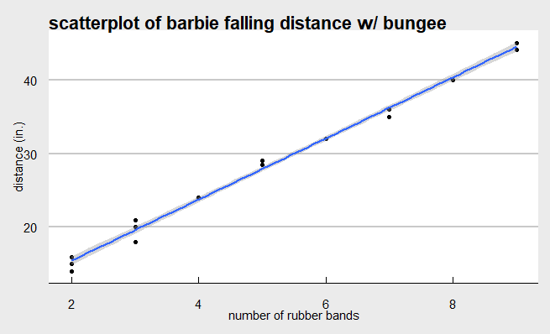

3. Conduct a hypothesis test to test the claim that the linear correlation coefficient / slope is different than zero. Show all 6 steps! Fill in the blanks:

|  |  |
| --- | --- |
| $$H_{0}: β_{1}=0$$ $$H_{A}: β_{1}≠0$$ $$\text{Critical Values:} ±2.073873$$ $$\text{Test Statistic:} 60.69$$ $$\text{P}\text{-}\text{value:}\text{ p < 2e-16}$$ $$\text{Decision:}\text{ Reject} H_{0}$$ | **Conclusion:**  There is overwhelming evidence at the alpha-0.05 level that the linear coefficient for the simple linear regression model is not zero (p-value < 0.00001). Our best estimate is that the true linear coefficient is 4.13690 and we are 95% confident that the true slope is between 3.995545 and 4.278255. |

4. Was the linear correlation significantly different than zero? How do you know?

Yes, we can visually inspect to see that there is some positive correlation between number of rubber bands and falling distance. We also found that for the linear model: $Y=B_{0}+B_{1}*X$; our coefficient, $B_{1}$, was statistically significant at the alpha-0.05 level.

6. What is the estimate of the percent of the variation in the distance bungeed that is explained by the number of rubber-bands used?

The proportion of variation that can be explained regarding bungee distance that is explainable by the number of rubber bands used *is* the r-squared value from the linear model. This value was 0.9938, or 99.38%.

7. Calculate and write down the linear regression equation (if appropriate) (don’t use “y” and “X” … use “Distance” and “Num_RubberBands”:

8. Use R to find a confidence interval for the slope. Write the interval below as well as the margin of error (MOE). You can use the easy calculation for the MOE: (upper limit – lower limit) / 2

We are 95% confident that the true slope is between 3.995545 and 4.278255 inches. Our best estimate is .

9. Interpret the slope and the interval you found above:

For every one unit increase in number of rubber bands, there is an associated increase in the mean of the normal distributions of distance by 4.13690 inches, based on the model.

10. Interpret the intercept:

The y-intercept is the predicted value of the mean of the normal distribution of bungee distances for when the number of rubber bands is 0.

11. Would using the interpretation about the intercept be extrapolation? Why or why not?

It is extrapolation. We did not test a count of rubber bands of zero; therefore, predicting zero falls outside of the domain of the model.

12. Next … you have the opportunity to collect a little more information! You may take one more jump but this time we have a longer tape measure. Simply choose the number of rubber bands you want to test and line up to collect your extra data point. NOTE: You are increasing the variance of X (number of rubber bands)!: sx2 .

What number of rubber bands did you use in this extra drop? $30$

What is the sx2?

13. Next recalculate the intercept and slope using all your data points and write the new regression equation below.

14. What is the new confidence interval for the slope now that you have used all your data points? Recalculate the MOE and compare it to the one you found earlier. Which one is smaller?

Our best estimate for the slope is 3.925. We are 95% confident that the true slope for the linear model is between 3.852414 and 3.997586. Our new margin of error is 0.07258556. The new MOE is smaller because we were able to increase variance in our x-variable (*i.e.*, Number of Rubber Bands).

15. Provide a plot of your data with the regression line.

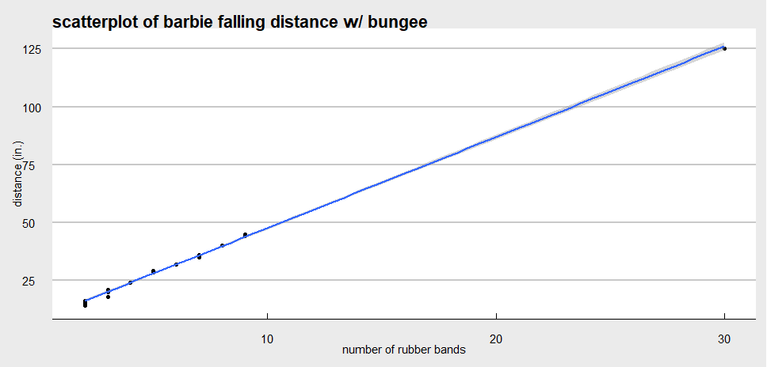

16. **Email this back to Bivin for Immersion credit! bsadler@smu.edu.**

17 We have measured the distance from the top to the bottom of the Hughes Trigg Bridge! It is 22ft 4 inches. Use your regression equation to estimate the number of rubber bands needed to bungee your super hero or Barbie that distance. The winner will bungee their subject closest to the ground without hitting any body part. Remember that it is ok if hair hits the ground but any other body part (hand, head, etc.) results in death or serious injury to super hero or Barbie and disqualification for you team! ☺

18. Start stringing those rubber bands together … then we are off to the Hughes Trigg Bridge!!!!!